**Exercise 1: Mocking and Stubbing**

package com.example;

import static org.junit.Assert.assertEquals;

import static org.mockito.Mockito.*;

import org.junit.Test;

import org.mockito.Mockito;

public class Myservicetest {

@Test

public void testExternalApi() {

Externalapi mockApi = Mockito.mock(Externalapi.class);

when(mockApi.getData()).thenReturn("Mock Data");

Myservice service = new Myservice(mockApi);

String result = service.fetchData();

assertEquals("Mock Data", result);

}

}

**ADD Dependency in pom.xml:**

<dependency>

<groupId>org.mockito</groupId>

<artifactId>mockito-core</artifactId>

<version>3.12.4</version>

<scope>test</scope>

</dependency>

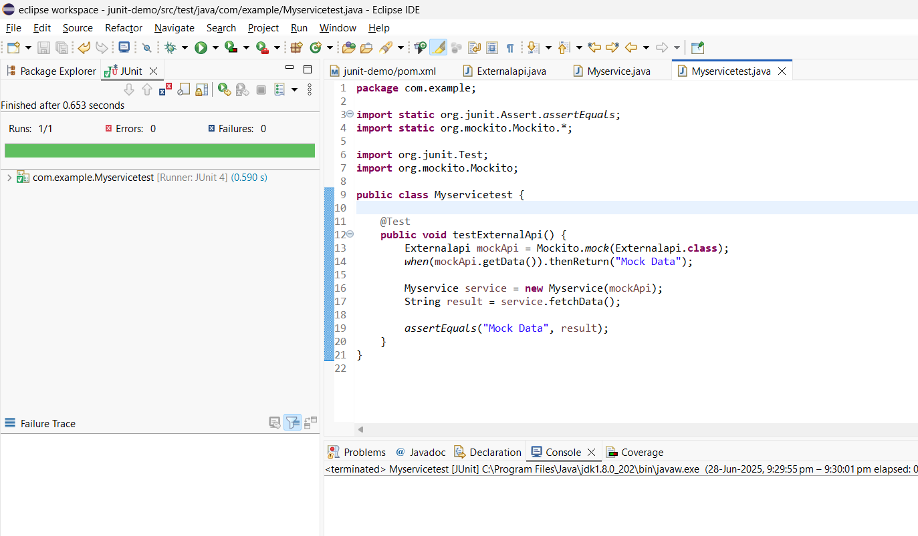

**Exercise 2: Verifying Interactions**

**package** com.example;

**import** **static** org.mockito.Mockito.*;

**import** **static** org.junit.Assert.*;

**import** org.junit.Test;

**public** **class** Myservicetest {

@Test

**public** **void** testVerifyInteraction() {

Externalapi mockApi = *mock*(Externalapi.**class**);

Myservice service = **new** Myservice(mockApi);

service.fetchData();

*verify*(mockApi).getData();

}

}

